

**Alpha-QA Technology Services, LLP**

**Business Requirement Documents**

**Project Name**: **Alpha-QA Software Testing**

**Prepared On: 28/05/2023**

**Prepared by: Ravi Kumar and Priyadharshini Krishnamoorthy**

**Table of Contents**

1. **Introduction**
   1. Project Overview
   2. Objectives
2. **Scope**
   1. In-Scope
   2. Out-of-Scope
3. **Stakeholders**
   1. Key Stakeholder
   2. Roles and Responsibilities
4. **Functional Requirements**
5. **Assumptions and Constraints**
   1. Assumptions
   2. Constraints
6. **Use Cases**

**6.1 User Registration Page**

6.1.1 Pre-conditions

6.1.2 Acceptance Criteria

6.1.3 Main Flow

6.1.4 Post Conditions

**6.2 Admin Login**

6.2.1 Pre-conditions

6.2.2 Acceptance Criteria

6.2.3 Main Flow

6.2.4 Post Conditions

**6.3 Forgot Password**

6.3.1 Pre-conditions

6.3.2 Acceptance Criteria

6.3.3 Main Flow

6.3.4 Post Conditions

**6.4 UserID**

6.4.1 Preconditions

6.4.2 Acceptance Criteria

6.4.3 Main Flow

6.4.4 Post Conditions

**6.5 Testing Topics**

6.5.1 Preconditions

6.5.2 Acceptance Criteria

6.5.3 Main Flow

6.5.4 Post Conditions

**6.6 Services Information**

6.6.1 Preconditions

6.6.2 Acceptance Criteria

6.6.3 Main Flow

6.6.4 Post Conditions

**6.7 Contact Information**

6.7.1 Preconditions

6.7.2 Acceptance Criteria

6.7.3 Main Flow

6.7.4 Post Conditions

**6.8 About Us**

6.8.1 Preconditions

6.8.2 Acceptance Criteria

6.8.3 Main Flow

6.8.4 Post Conditions

1. **Approval and Sign-off**
2. **Introduction:**

**1.1 Project Overview:**

Alpha-QA Software Testing provides information on the software testing concepts, especially on the core topics. It defines the concepts of testing, techniques, advantages and disadvantages.

**1.2 Objectives**:

Provides Core testing topics, in place of comprehensive coverage of testing concepts.

1. **Scope:**

**2.1 In-Scope:**

Target on the core testing concepts.

**2.2 Out-of-Scope:**

Not focused on the comprehensive coverage of testing concepts.

1. **Stakeholders:**

**3.1 Key Stakeholder:**

Sujith Kumar

**3.2 Roles and Responsibilities:**

Providing feedback, clarifying the requirements, and ensuring the final outcome meet their needs.

1. **Functional Requirements:**

* New User Registration
* Login Form
* Forgot Password
* Navigation Menu
* Testing Topics
* Services Information
* Contact Information
* About Us

1. **Assumptions and Constraints:**

**5.1 Assumptions:** Stakeholder has provided information based on the business process and requirements.

**5.2 Constraints:** Project completed within a specific timeframe.

1. **Use Cases:**

**6.1 New User Registration**

**6.1.1 Preconditions**

User must have the necessary information to complete the registration.

**6.1.2 Acceptance Criteria**

* All of the available required fields display in the Register form.
* Required fields contains the Username, Email ID, Password, and Confirm Password.
* Users can only register a form by filling in all required fields.
* After clicking register button, receive a pop-up message “Register Successfully”.

|  |
| --- |
| **Register**  **User name**  Enter User name  **Email ID**  Enter email id  **Password**  Enter Password  **Confirm Password**  Re-Enter Password    **Register**  **Already have an account**? **Login** |

**6.1.3 Main Flow**

**6.1.4 Post Conditions**

User successfully completes the registration process and receive a pop-up message “Register Successfully”.

* 1. **Login Form**

**6.2.1 Preconditions**

Users must have an account to login.

**6.2.2 Acceptance Criteria**

* All of the available required fields display in the Login form.
* Users should be able to log in successfully with correct username and password.
* User should receive appropriate error message when entering invalid credentials.
* Users should be able to reset their password through a password recovery process.
* If users were not already registered with the account, they can create an account using the "Register" button.

**6.2.3 Main Flow**

|  |
| --- |
| **Login**  **Username**  Enter Username  **Password**  Enter Password  **Forget Password?**  **Login**  **New User? Register** |

* + 1. **Post Conditions**

After successfully logged in, users should have access to the appropriate application.

**6.3 Forgot Password**

**6.3.1 Preconditions**

User has access to the email account associated with their account for the password recovery.

**6.3.2 Acceptance Criteria**

* User click on the “Forgot Password” link, they are redirected to a password recovery page.
* On the password recovery page, the user is to enter their valid email address.
* Once submit button is clicked, the user receives an email with a password reset link.
* Clicking on the password reset link, redirects the user to a page where they can enter a new password.
* After successfully resetting the password, the user should be redirected to the login page and notified of the password changed successfully.
* The user should be able to log into the system using the new password.

**6.3.3 Main Flow**

|  |
| --- |
| **Forgot Password?**  **Email**  **Submit**  Enter valid email  Back to **Login** |

**6.3.4 Post Conditions**

User receives an email and able to successfully reset their password and log into the system.

**6.4 Navigation Menu**

**6.4.1 Preconditions**

User Interface includes a navigation menu and the user can able to navigate to each item.

**6.4.2 Acceptance Criteria**

* The Navigation menu is visible and able to access the functionalities associated with each menu item.
* Clicking on a menu item takes the user to the corresponding section of the item.
* The user's current access to the active menu item is shown by its highlight or differentiation.

**6.4.3 Main Flow**

|  |
| --- |
| **ALPHA-QA Home Topics Contact Services About** |

**6.4.4 Post Conditions**

User can access the functionalities associated with each menu item.

**6.5 Testing Topics**

**6.5.1 Preconditions**

Brief description on the testing topics, techniques, advantages and disadvantages.

**6.5.2 Acceptance Criteria**

* The “Testing Topics” page should be accessible from the website’s main navigation menu.
* The user's current access to the topic’s menu item is shown by its highlight or differentiation.
* When clicking on the specific item, takes the user to the corresponding information of the item.
* Each topics includes the key notes of concepts (WWW-what, when, why), techniques, advantages and disadvantages

|  |
| --- |
| **Topics**  Unit Testing  Integration Testing  System Testing  Smoke Testing  Sanity Testing  System Integration Testing  Performance Testing  Regression Testing  Security Testing  Compatibility Testing  Acceptance Testing  User Acceptance Testing  Alpha Testing  Beta Testing |

**6.5.3 Main Flow**

**6.5.4 Post Conditions**

User should able to access the information for the topics listed.

**6.6 Services Information**

**6.6.1 Preconditions**

Primary focus on the Plan 1: Core Testing Concepts.

**6.6.2 Acceptance Criteria**

* The “Services Information” page should be accessible from the website’s main navigation menu.
* Provide information about the importance of Core Testing Concepts.
* Service on the Core Concepts is the main priority, with later plans being extended.

**6.6.3 Main Flow**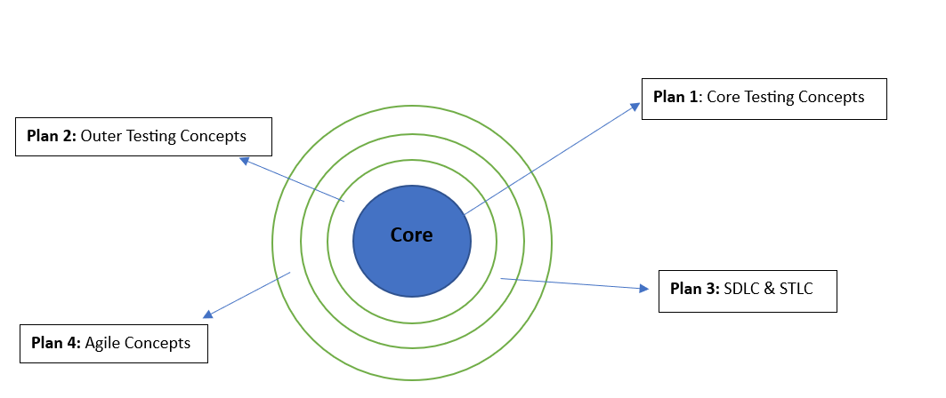

**6.6.4 Post Conditions**

Users should be able to view an available service**.**

**6.7 Contact Information**

**6.7.1 Preconditions**

Contact information is available to users, is current, and is up to date.

**6.7.2 Acceptance Criteria**

* The “Contact Information” page should be accessible from the website’s main navigation menu.
* Contact details should include all necessary information for users to get in touch, such as name, physical address, email address, and any additional contact details deemed relevant.
* External links on the page should be valid and point to the right sources.

**6.7.3 Main Flow**

|  |
| --- |
| **Contact 1**  **Name:** Ravi Kumar  **Company Name:** Alpha-QA Technology Services, LLP  **Email ID:** ravikumar17072002@gmail.com |

|  |
| --- |
| **Contact 2**  **Name:** Priyadharsini  **Company Name:** Alpha-QA Technology Services, LLP  **Email ID:** priyadharsinik317@gmail.com |

**6.7.4 Post Conditions**

Contact information should be displayed and available for users to access**.**

**6.8 About Us**

**6.8.1 Preconditions**

Provide information to the users about the Alpha-QA Software Testing.

**6.8.2 Acceptance Criteria**

* The “About Us” page should be accessible from the website’s main navigation menu.
* Page should contain accurate information about the website, such as team members.

**6.8.3 Main Flow**

|  |
| --- |
| **About Us**  Priyadharshini, Graduate in Electronics and Communication Engineering at Karunya University and Ravikumar, Graduate in Mechanical Engineering at Karpagam College of Engineering. We both planned to create an Alpha-QA Software Testing, aimed to build a Core testing idea in favor of in-depth testing concepts. Both beginners and experienced will benefit much from thoroughly understanding the key testing ideas. |

**6.8.4 Post Conditions**

Information should be reliable and users can view information at any time.

1. **Approval and Sign-Off**

Sujith Kumar-Project Manager